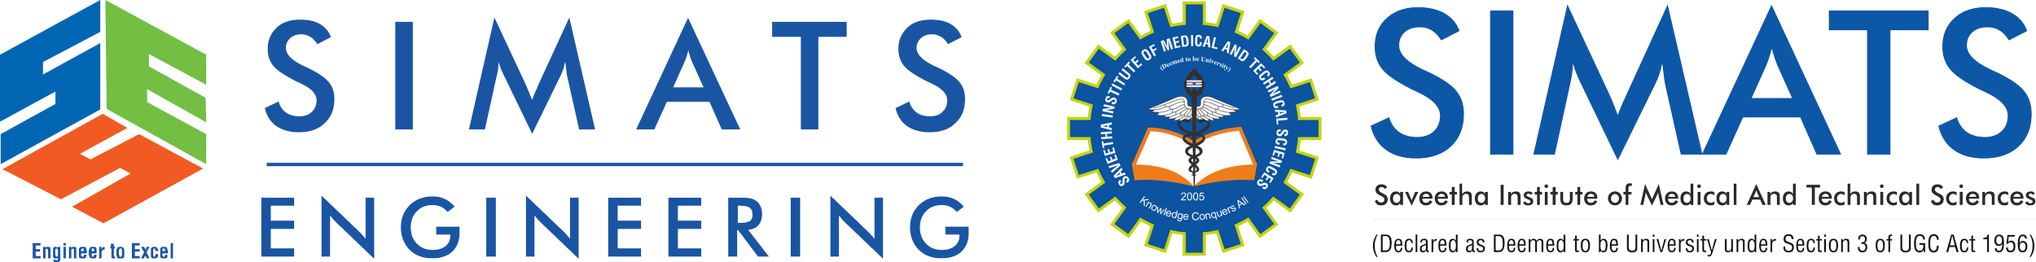
Algorithm Analysis Fundamentals
Time complexity analysis of iterative and recursive algorithms; verify BigO, Ω, Θ for sample programs

NAME: Karthikeyan k
REG NO: 192425072

Experiment 1: Linear Search (Iterative)
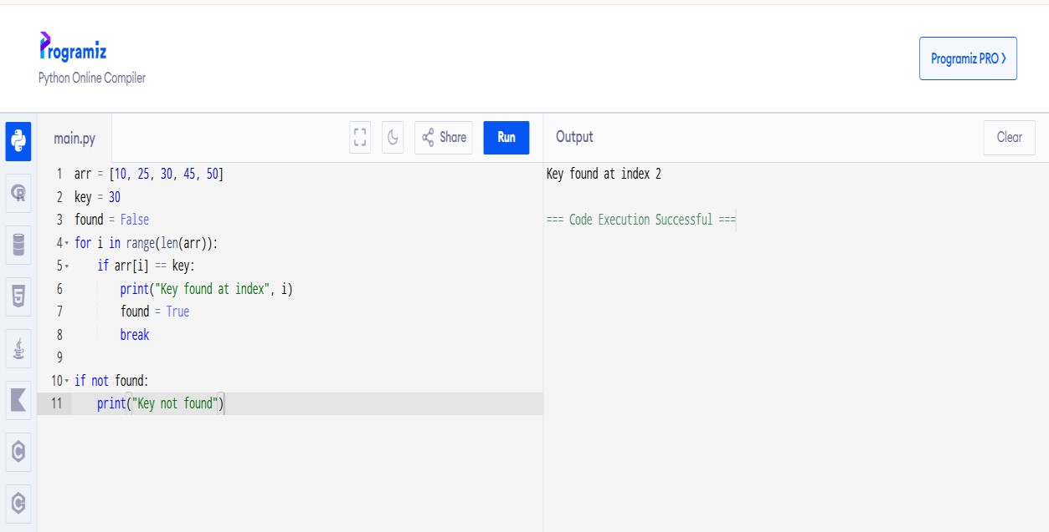

Experiment 2: Binary Search (Recursive)
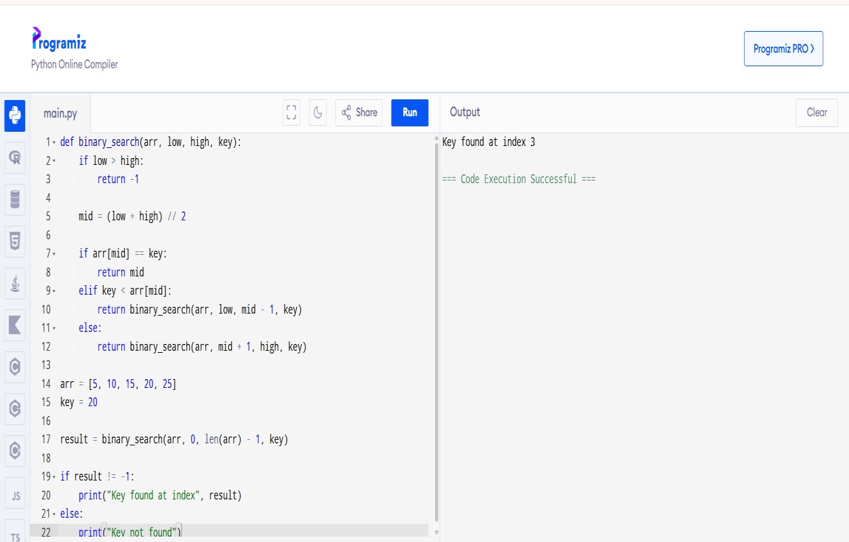

Experiment 3: Factorial (Iterative and Recursive)
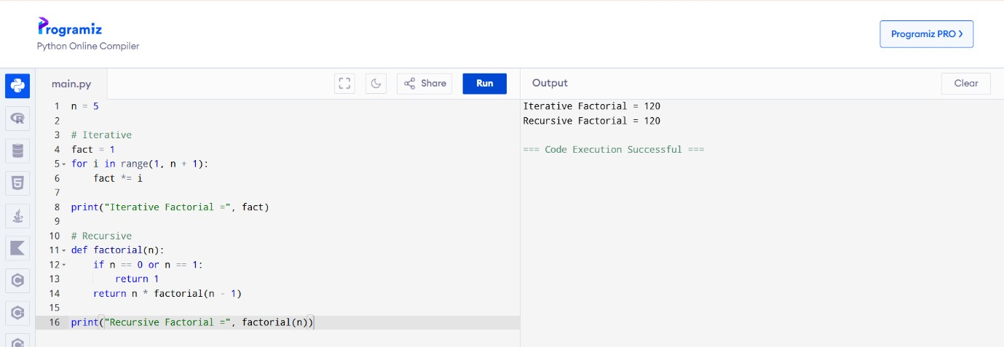

Experiment 4: Fibonacci Series
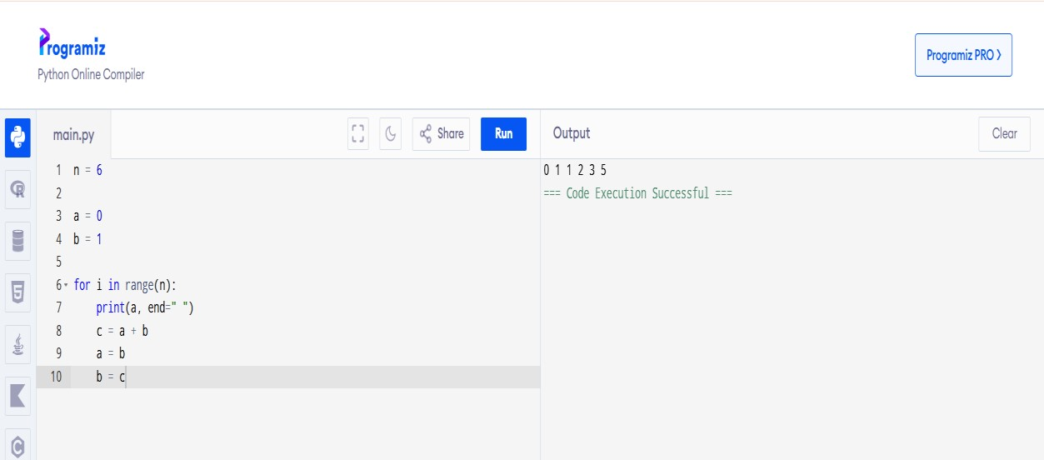

Experiment 5: Matrix Multiplication
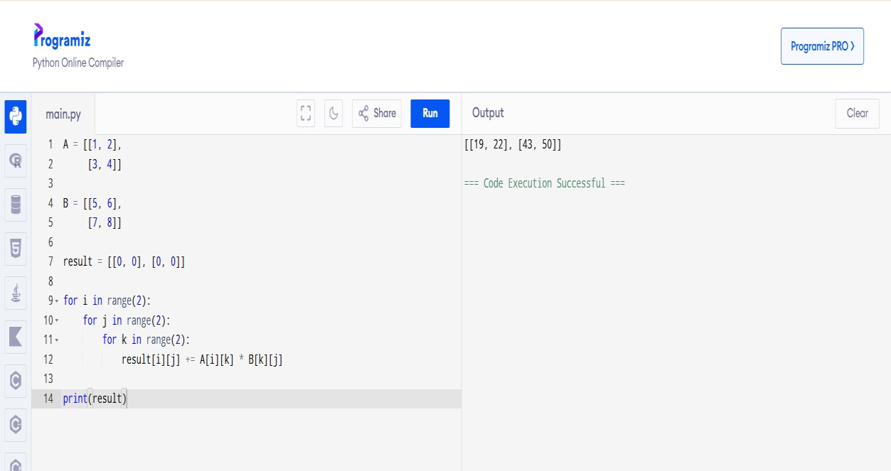

Experiment 6: Merge Sort

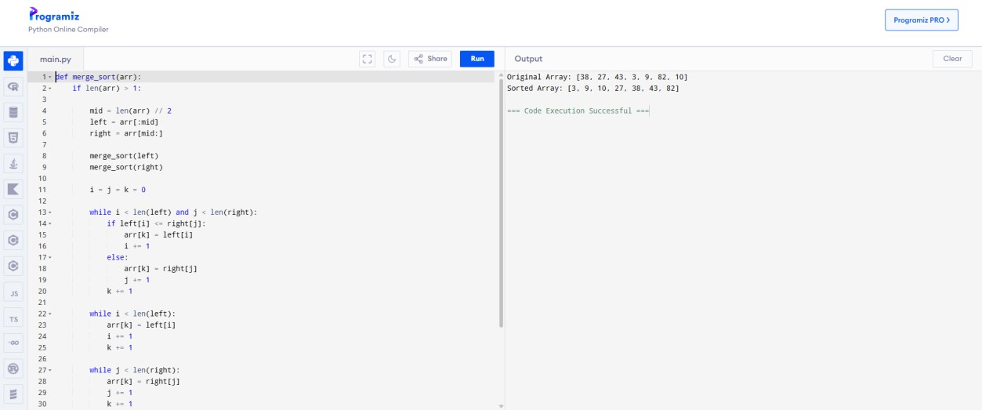

Experiment 7: Quick Sort
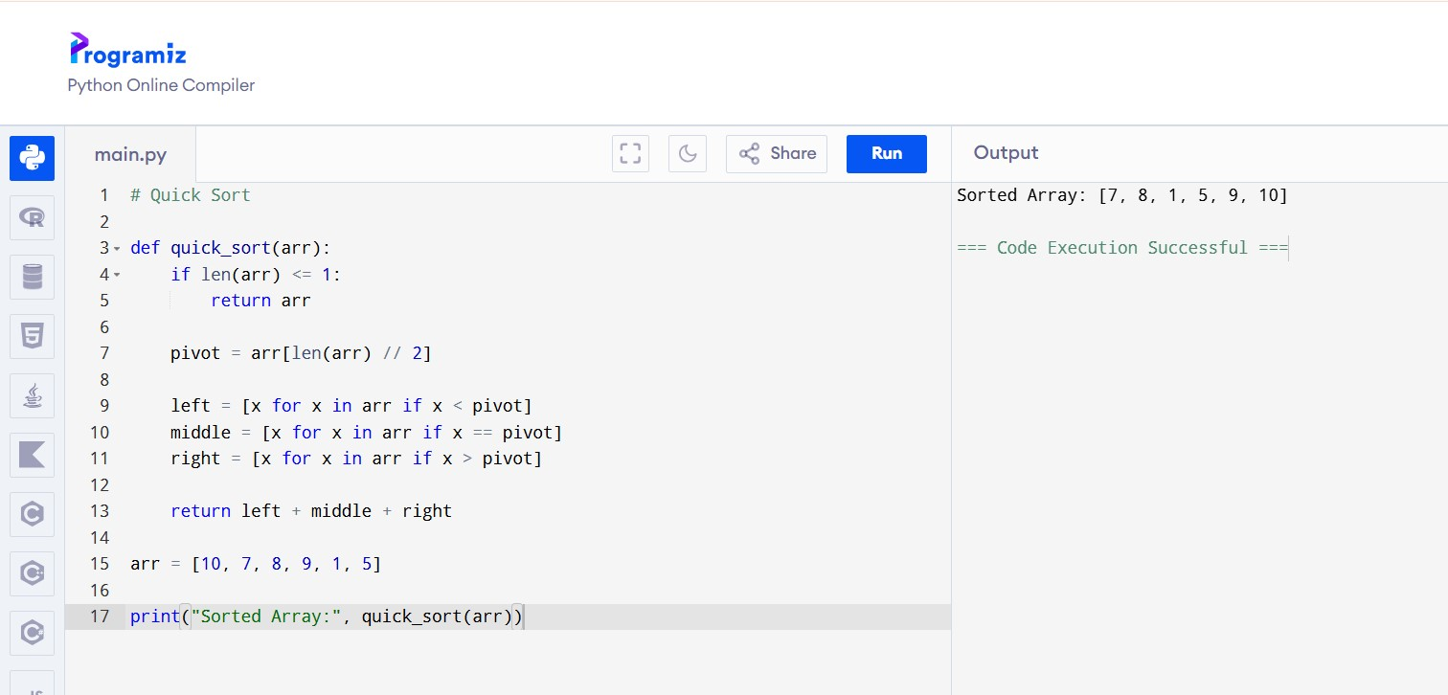

Experiment 8: Tower of Hanoi
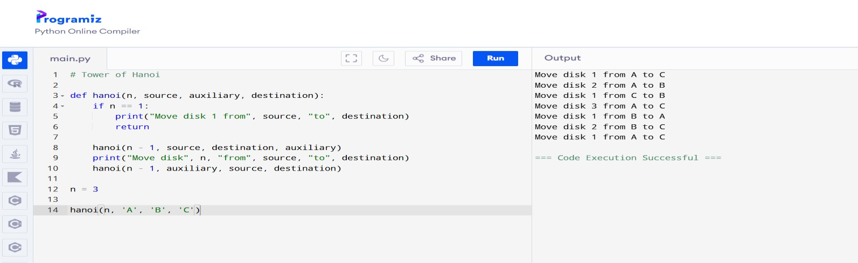

Experiment 9: GCD (Euclidean Algorithm)
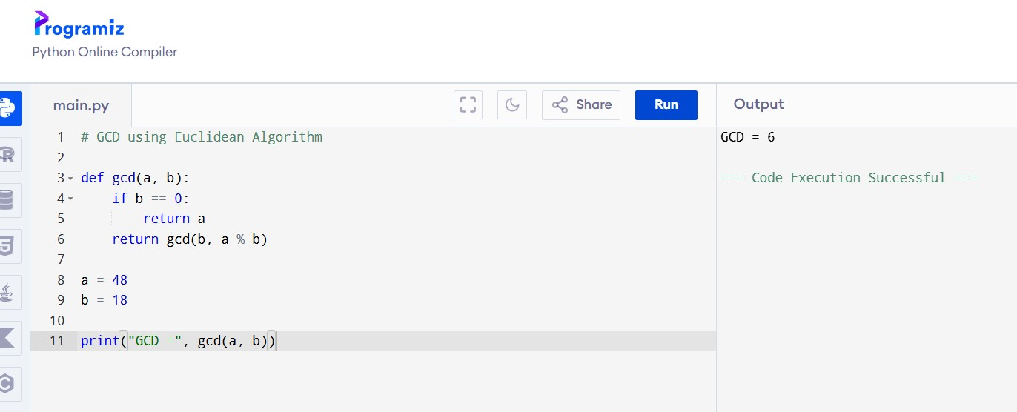
Experiment 10: Insertion Sort
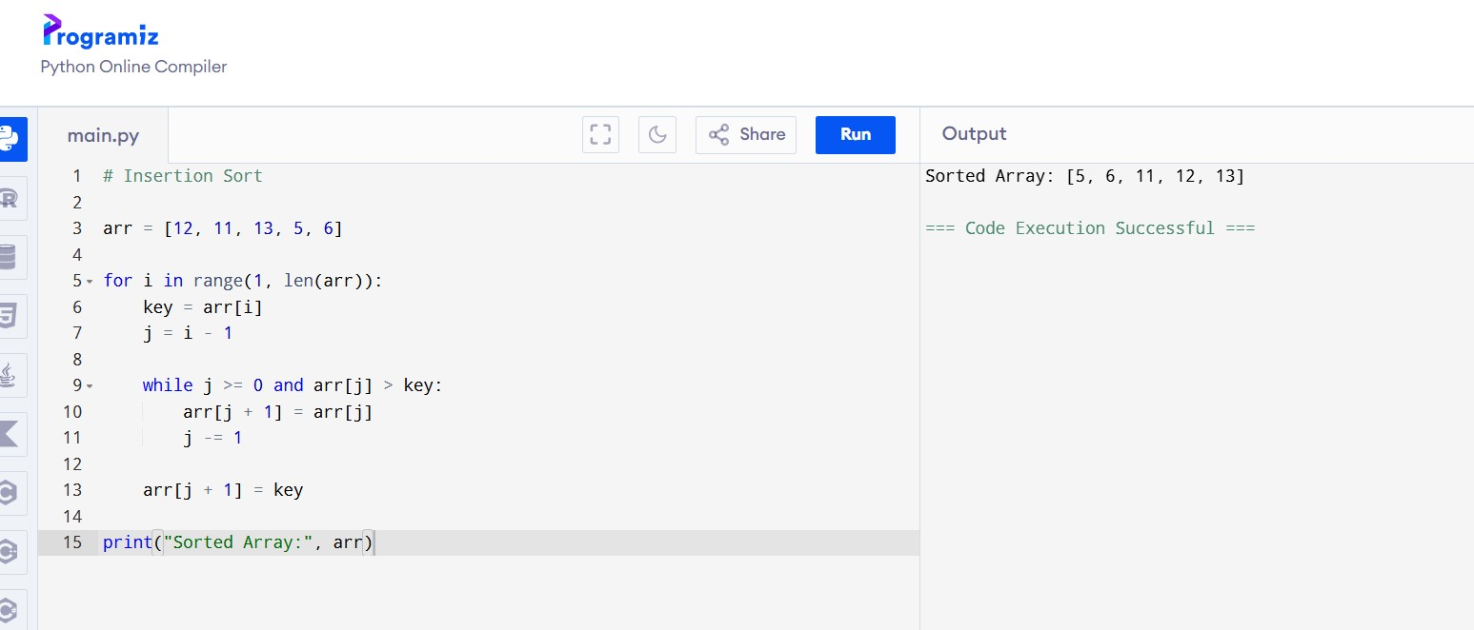

Experiment 11: Heap Sort
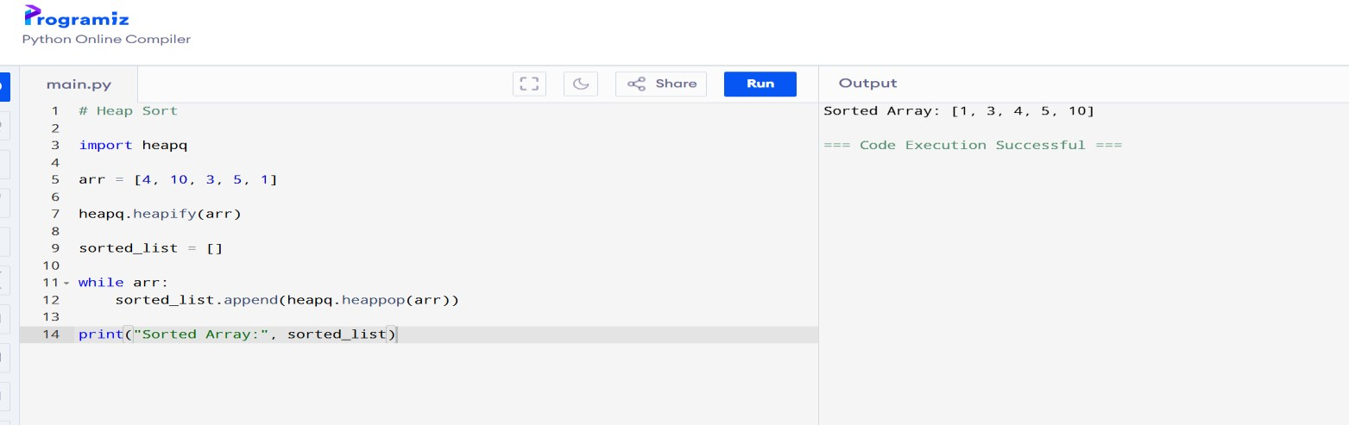

Experiment 12: Counting Inversions

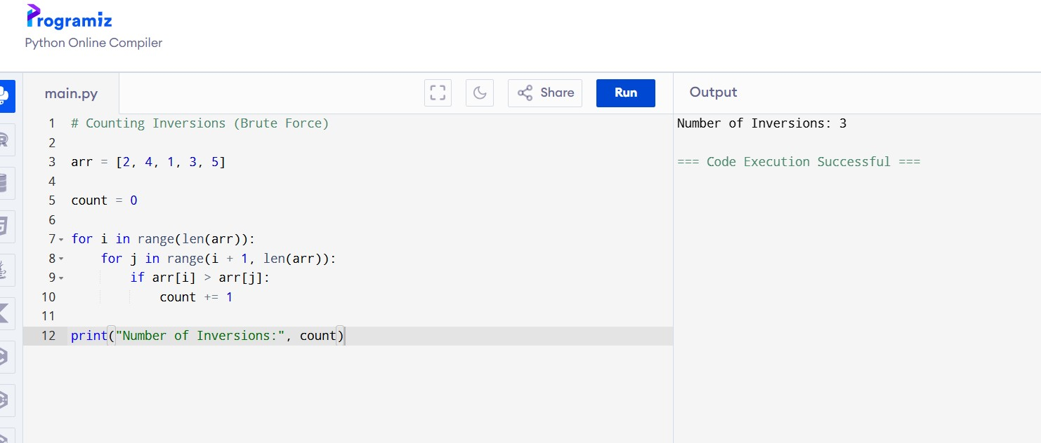

Experiment 13: Maximum Subarray Sum (Kadane's Algorithm)
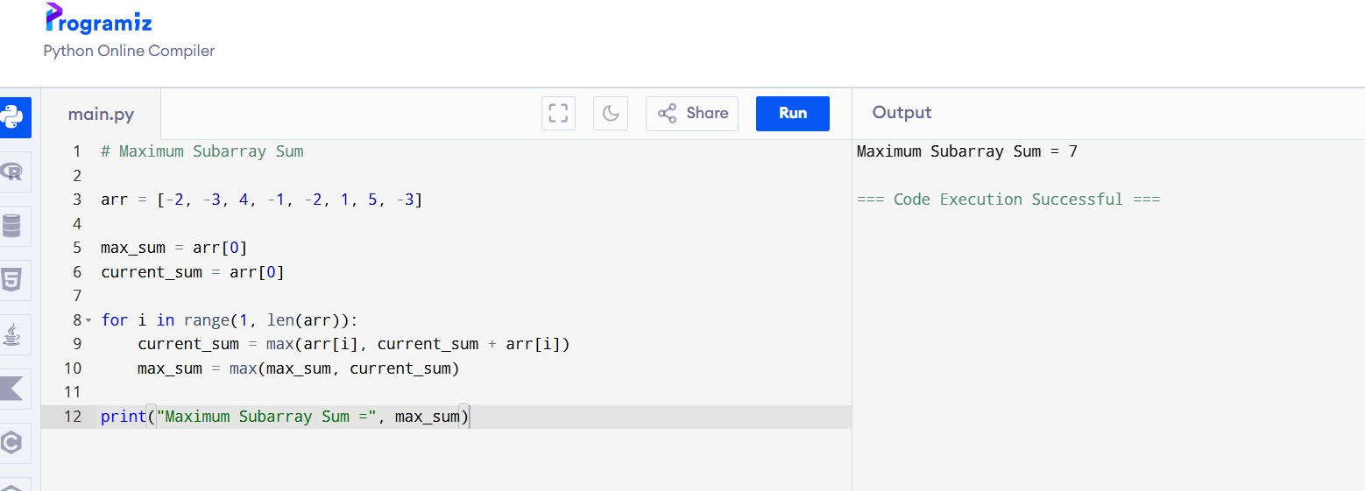
Experiment 14: Exponentiation (Fast Power)
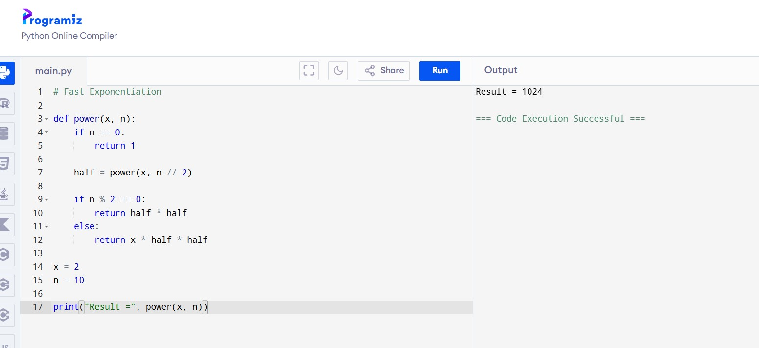

Experiment 15: Closest Pair of Points (Brute Force)

